**Christopher King**

**2018141521058**

**Mechanical Design 2**

**Class Section 01**

**09/23/2021**

# **Problem 1**

A solid square rod is cantilevered at one end. The rod is 0.6 m long and supports a completely reversing transverse load at the other end of ±2 kN. The material is AISI 1080 hot-rolled steel. If the rod must support this load for 10,000 cycles with a design factor of ~1.5, what dimension should the square cross section have? Since the size is not yet known, assume a typical value of kb = 0.85 and verify its correctness later. Neglect any stress concentrations at the support end.

**Solution:**

For this question, we are asked to determine the dimension that the square cross section should have.

From Table A-20, I can get that the ultimate strength of AISI 1080 hot-rolled steel is equal to

Therefore, the endurance limit is equal to

Next, we consider to modify the endurance limit.

Surface Condition (hot-rolled):

Size Effect:

Loading Effect (bending):

Temperature Effect (room temperature):

Reliability Effect:

Therefore, the modified endurance limit is equal to

From Figure 6-18, I can know that the fatigue strength fraction is equal to

Therefore,

From the force diagram, I can know that

And

Check for the size effect:

The result doesn’t match our guess.

Therefore, I conduct the iteration to determine the dimension of the beam.

clc; clear all;

kb = 0.85;

for i = 1:20

Sut = 770;

f = 0.83;

ka = 57.7*770^(-0.718);

Se = ka*kb*385;

a=(f*Sut)^2/Se;

b=-1/3*log10((f*Sut)/Se);

Sf = a*10000^b;

bb = (1.5*7200/(Sf*1E6))^(1/3);

de=0.808*bb*1000;

kb = (de/7.62)^(-0.107);

end

After conducting 20 iterations, the value of is converged to and the value of size is converged to .

# **Problem 2**

The shaft shown in the figure is machined from AISI 1040 CD steel. The shaft rotates at 1600 rpm and is supported in rolling bearings at A and B. The applied forces are F1 = 2500 lbf and F2 = 1000 lbf. Radius of all fillets is 1/16 in R.

Determine the minimum fatigue factor of safety based on achieving infinite life. If infinite life is not predicted, estimate the number of cycles to failure. Also check for yielding.

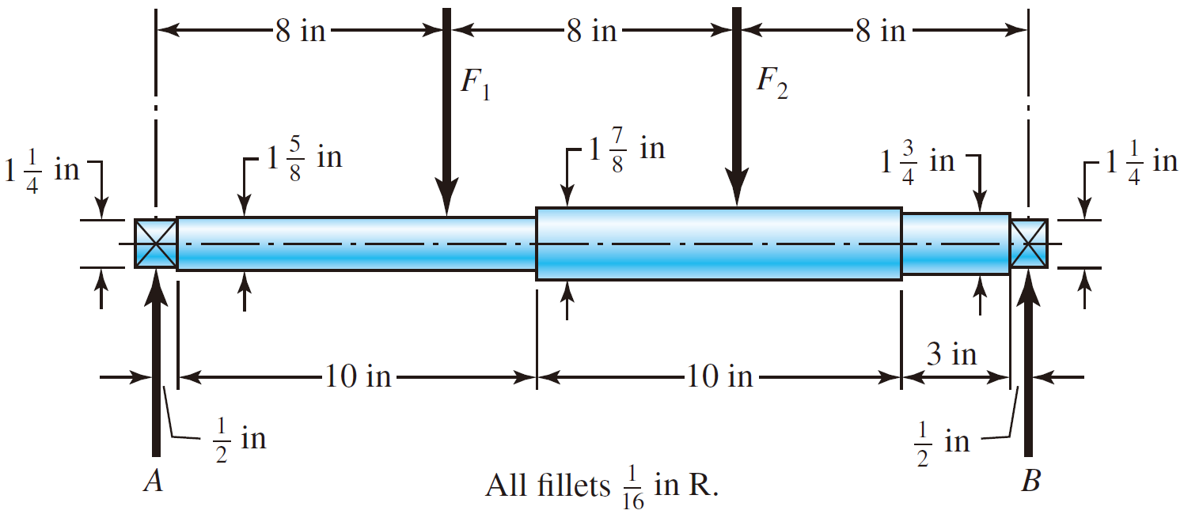

**Solution:**

For this question, we are asked to determine the minimum fatigue factor of safety based on achieving infinite life. If infinite life is not predicted, estimate the number of cycles to failure. Also check for yielding.

From Table A-20, I can get that the ultimate strength and yield strength of AISI 1040 CD steel is equal to

Therefore, the endurance limit is equal to

Next, we consider to modify the endurance limit.

Surface Condition (cold drawn):

Size Effect ():

Loading Effect (bending):

Temperature Effect (room temperature):

Reliability Effect:

Therefore, the modified endurance limit is equal to

From the force diagram, I can know that the bending moment at the second fillet is equal to

According to Figure A-15-9, when and , the stress concentration factor is equal to

The fatigue stress concentration is equal to

Therefore, the fatigue factor of safety is equal to

Hence, I can know that infinite life is not predicted.

From Figure 6-18, I can know that the fatigue strength fraction is equal to

Therefore,

The safety factor for yield strength is equal to

# **Problem 3**

Shaft A, made of AISI 1020 hot-rolled steel, is welded to a fixed support and is subjected to loading by equal and opposite forces F via shaft B. A theoretical stress concentration factor Kts of 1.6 is induced in the shaft by the 1/8-in weld fillet. The length of shaft A from the fixed support to the connection at shaft B is 2 ft. The load F cycles from 150 to 500 lbf.

1. For shaft A, find the factor of safety for infinite life using the modified Goodman fatigue failure criterion.
2. Repeat part (a) using the Gerber fatigue failure criterion.

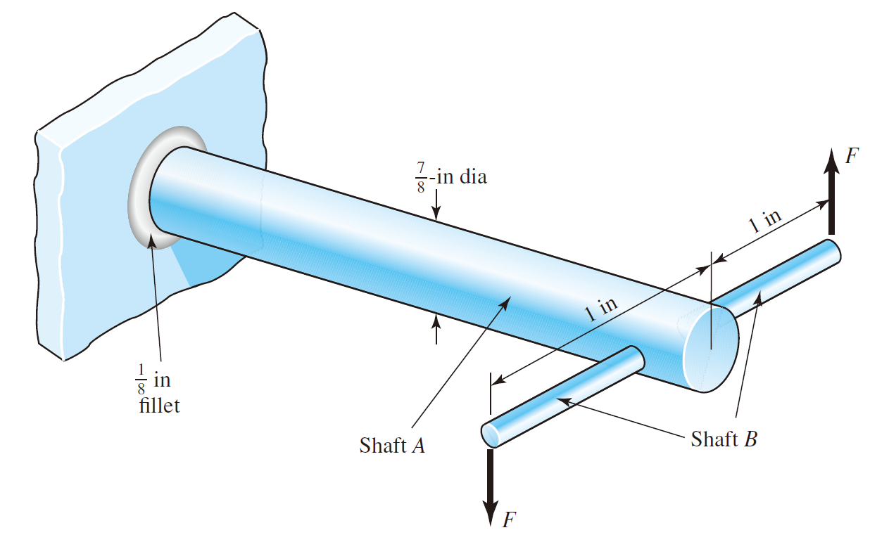

**Solution:**

1. For this question, we are asked to find the factor of safety for infinite life using the modified Goodman fatigue failure criterion for shaft A.

From Table A-20, I can get that the ultimate strength of AISI 1020 hot-rolled steel is equal to

Therefore, the endurance limit is equal to

Next, we consider to modify the endurance limit.

Surface Condition (hot-rolled):

Size Effect ():

Loading Effect (torsion):

Temperature Effect (room temperature):

Reliability Effect:

Therefore, the modified endurance limit is equal to

And because the stress in this question is torsion,

The fatigue stress concentration is equal to

From the question, I can know that

The safety factor for yield strength is equal to

And, in constructing the Goodman diagram, I use

Then implement the Modified Goodman failure criterion:

1. For this question, we are asked to find the factor of safety for infinite life using the Gerber fatigue failure criterion for shaft A.

Implement the Gerber fatigue failure criterion: